Cairo University Faculty of Computers and Information



**Software Engineering II**

**Software design specification document**

**2020**

**Project Team**

|  |  |  |  |
| --- | --- | --- | --- |
| **ID** | **Name** | **Email** | **Mobile** |
| 11422019465782 | Ahmed Samir Mohammed | ahmed.99.samir@gmail.com | 01149412010 |
| 11422018499845 | Ashraf Adel Mohamed | ashrafadel645@gmail.com | 01013640462 |
| 11422018499851 | Rana Mohamed Elmetwally | rana.m7md.2014@gmail.com | 01114754043 |
| 11422018499848 | Eman Mostafa Mohamed | m.eman99@yahoo.com | 01022253155 |

**T.A Mohamed Samir**

Title page has no header or footer.

Docs must be supplied as pdf –files re-named as requested

Contents

Class diagram design 3

Github repository link 3

# Class diagram design

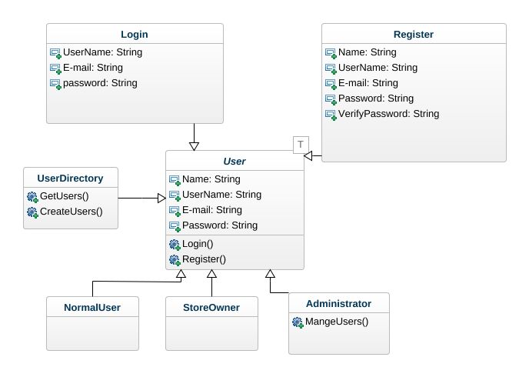

# Github repository link

* <https://github.com/engahmed99/pre_masters-sw2-online-store-platform>